**SENDA Accessibility Plan**

| **Responsible person:** Matt Farrah/ Paul Jones  **Review Cycle:** Triennial  **Last review date:** January 2024  **New review date:** January 2027 |
| --- |

**In all Burlington House School policies, the words “Burlington House School” refer to Burlington House Prep, Burlington House Senior, Burlington House Sixth Form, and Burlington House School Tooting.**

Burlington House School Tooting is owned and operated by **Cavendish Education.**

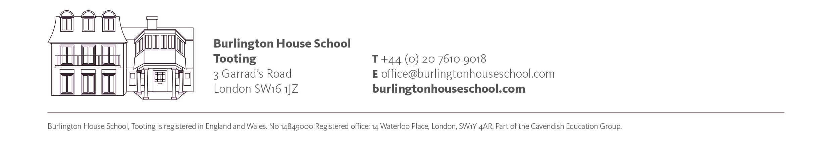

The school adheres to the regulations and guidance in the ISI regulatory standards and the law set out in Schedule 10 of the Equality Act 2010. This policy refers to disabled people, including those with special educational needs.

At Burlington House School Tooting we will:

* Not treat disabled people less favourably
* Take reasonable steps to avoid putting disabled people at a substantial disadvantage (the ‘reasonable adjustment’ duty) in matters of admission and education.

This three-year plan includes how the school plans to:

1. Increase the extent to which disabled pupils (including those with special educational needs) **can participate in** the school’s curriculum
2. Improve the provision to disabled pupils of **information which is already in writing** for pupils who are not disabled
3. Improve the physical environment of the school in order to increase the extent to which any pupils with disabilities are able to take advantage of education and associated services offered by the school.

To increase the extent to which disabled pupils (including those with special educational needs) **can participate in** the school’s curriculum:



| **Objective** | **By when?** | **By whom?** | **Resources** | **Review** |
| --- | --- | --- | --- | --- |
| To review and revise signage in all areas of the school to ensure legibility and use of symbols wherever possible* | April 2024 | KC/PJ | New signage where needed | December 2024 |
| To improve delivery of multisensory lessons by auditing teaching and learning to pupils with SEND. | On-going | All teaching staff. | Time for classroom observations and appraisals | December 2024  Subsequent monitoring through T and L reviews/ learning walks. |
| To improve pupils’ access to pencil grips, and multisensory accessories to help with specific difficulties inc. attention deficit by providing each classroom with an ‘SEND Toolbox’ | To be introduced from April 2024 | PJ | OT Budget | SEN Toolkits in place and regularly utilised from April 2024.  Equipment updated as required. |
| To improve posture, balance, strength, flexibility and mindfulness in identified pupils by providing specialist exercise sessions. | From September 2024 | OT - BDV | Time allocated on Integrated Therapy Timetable | Review December 2024 and ongoing |
| To improve attention and concentration of pupils in lessons by introducing Brain Gym. | To be introduced from April 2024 | OT - BDV | Time | BDV to provide ongoing INSET training to all Burlington staff |
| Train staff in teaching methods/use of equipment to help support the learning of pupils identified as having hearing impairment. | Ongoing | SENCo and all staff | CPD and Twilight Training to incorporate this training as and when needed. | SENCo to monitor |
| Introduce mindfulness sessions in order to improve social and emotional wellbeing of pupils. | To be introduced from April 2024 | AEH | Allocated time | December 2024 |

*\* Note, due to the specialist nature of the school as a provision for pupils with dyslexia, all pupils in the school have difficulty accessing written information.*

**

| **Objective** | **By when?** | **By whom?** | **Resources** | **Review** |
| --- | --- | --- | --- | --- |
| Rolling programme of equipment maintenance and replacement | Ongoing | OT | Replacement equipment for  Sensory Toolkits | As needs arise |
| OT-Introduction of Zones of Regulation Programme | Introduced January 2024 | SENCo - Staff training provided in January 2024 | Shared on the day | Termly |
| English Department- Assistive Technology software and headphones | April 2024 | MF (HoF) | Headphone/ speech to text | Termly |
| Crazy paving stones to be inspected and made secure | April 2024 | ACS Professionals In Construction | N/A | KC |
| Building works planned for 2025 - improved entrance access | In place, final sign off in August 2025 | ACS Professionals In Construction | N/A | KC/CC |
| Wheelchair accessibility secured for visitors | In place, final sign off in August 2025 | ACS Professionals In Construction | N/A | KC/CC |

To improve the provision to disabled pupils of **information which is already in writing** for pupils who are not disabled;

*\* Note, due to the specialist nature of the school as a provision for pupils with dyslexia, all pupils in the school have difficulty accessing written information. As such, our day to day function is based on a model which provides additional support for pupils to access written information. Details of the way in which we provide for this are available in our SEN Policy and SEN SEF and DEV Plans.*

**

| **Objective** | **By when?** | **By whom?** | **Resources** | **Review** |
| --- | --- | --- | --- | --- |
| Increase number of coloured overlays pupils have access to in classrooms (using SEN toolbox) | Sept 2021 | ND/MC | Coloured overlays | Annual update of SEN toolboxes in classrooms. |
| To include more rigorous reading data from a well-respected standardised test in tracking data by administering YARC test and GL assessment. | Sept 2020  Sept-2021  Sept-2022  Annual ongoing | SaLTs | GL assessment | Review annually. |
| To provide access to Paired Reading for all pupils in the school | Sept 2021 | All staff | Time | Paired reading offered to all pupils in the school from September 2021. Ongoing |
| All current teaching staff and LSAs to be trained to meet needs of learners with SpLD at postgraduate level. | Ongoing | MP | Training Budget | Review annually based on numbers of new staff |
| Introduce series of twilight specialist INSETs | Sep 2021 | ND | Training budget | Review annually |
| Introduce further training for key staff to deliver intervention programmes | May 2021  September 2023 | ND  TB | Training budget | Review annually |

To improve the physical environment of the school in order to increase the extent to which disabled pupils are able to take advantage of education and associated services offered by the school.

Signed: Date:

___________________________________________ _____________________

(Chair of Governors, on behalf of the governing body)

